**ABSTRACT**

The "Netflix Clone Website" mini project incorporates PHP and SQL to create a web application that emulates the core features and user experience of the renowned streaming platform, Netflix. This project harnesses a combination of front-end technologies, including HTML, CSS, and JavaScript, alongside PHP for server-side scripting and SQL for database management.

This "Netflix Clone Website" mini project not only provides valuable experience in web development but also emphasizes the integration of PHP and SQL in building a dynamic and data-driven web application. By successfully replicating the key features of Netflix, participants gain hands-on experience in developing a modern, interactive web platform while showcasing their proficiency in PHP and SQL for web development.

**ACKNOWLEDGEMENT**

We are extremely delighted to get an opportunity to express our gratitude for all those good souls who were more than guiding stars in helping us to complete the project.

We are deeply indebted to our In-charge Principal Dr. Javed Shaikh and Head of the Department Er. Abdul Sayeed. Their valuable feedback helped us tremendously to improve our project in many ways.

We also express our profound gratitude to our guide (Er. Samana Jafri) for constantly helping us with our project. We also give our thanks to the lab in charge for allowing us to access the utilities of our college.

|  |  |  |
| --- | --- | --- |
| **FIGURE NUMBER** | **FIGURE NAME** | **PAGE NUMBER** |
| **1** | **Home Page** | **28** |
| **2** | **FAQS page** | **29** |
| **3** | **Sign in Page** | **30** |
| **4** | **Sign Up Page** | **30** |
| **5** | **Movies Page** | **31** |

**LIST OF FIGURES**

**CHAPTER 1**

**INTRODUCTION**

**1.1) INTRODUCTION:**

Enter the world of the "Netflix Clone Website" mini project, a web development endeavor that pays tribute to the popular streaming platform by replicating its user interface and experience. Using a blend of front-end technologies like HTML, CSS, and JavaScript, alongside PHP and SQL for back-end operations, this project creates a visually captivating, responsive platform. It incorporates user registration, authentication, and a database filled with metadata, images, and content, offering a Netflix-like experience. PHP and SQL are employed for personalized content playback, recommendations, making it a comprehensive and interactive web application that showcases web development skills while honoring the world of streaming entertainment.

**2.2) MOTIVATON:**

Our motivation behind developing the "Netflix Clone Website" is driven by a fervent desire to recreate the magic of the world's favorite streaming platform and bring it to the fingertips of aspiring web developers. This project is fueled by a passion for web development and the pursuit of hands-on experience in front-end and back-end technologies, including HTML, CSS, JavaScript, PHP, and SQL. We are inspired to replicate Netflix's visually captivating and user-friendly interface, offering users a seamless and personalized experience. Our motivation is to learn and showcase the art of web development while creating a platform that pays homage to the entertainment industry giant.

**1.3) PROBLEM STATEMENTS AND OBJECTIVES:**

Designing and building a "Netflix Clone Website" project is our endeavor to tackle the challenges of replicating a popular streaming platform's user experience, catering to the needs and preferences of streaming enthusiasts and aspiring web developers alike. The project's primary goals encompass:

- User Experience Excellence

- Replication of Core Features

- Learning and Skill Showcase

- Seamless Responsive Design

- Recommendations Engine

- Database Management and Security

Our project aims to provide a rich and engaging user experience, mirroring the best aspects of the original platform, and fostering a platform that not only replicates but also extends the user's interaction with digital entertainment.

**1.4) ORGANIZATION OF REPORT:**

In our "Netflix Clone Website" project, we structure our approach as follows:

Chapter 1: Introduction

Chapter 2: Literature Review

Chapter 3: Design and Implementation

Chapter 4: Appendices

**CHAPTER 2**

**LITERATURE SURVEY**

**2.1) SURVEY OF THE EXISTING SYSTEM:**

The realm of online streaming platforms has witnessed remarkable advancements in recent years, transforming the way we consume digital content. These platforms have become integral to the entertainment industry, offering a vast library of movies and TV shows for users to access from the comfort of their own screens. Existing streaming platforms, such as Netflix, have set high standards in user interface design, content delivery, and recommendation algorithms. They have successfully captured the essence of user personalization, providing a seamless and engaging entertainment experience.

Numerous streaming services are already available in the market, each vying for the attention of viewers. They offer an array of features, including content categorization, user profiles, and recommendation engines, catering to a diverse audience with varying tastes and preferences. These platforms have not only simplified the way we access and enjoy content but have also set a benchmark for streaming quality, ensuring a consistent and enjoyable viewing experience.

Nevertheless, challenges persist in this competitive landscape. Issues like content licensing, regional restrictions, and ensuring a diverse and engaging content library are hurdles that streaming platforms must continually navigate. Furthermore, the ever-evolving technology landscape introduces opportunities for innovation and enhancements in areas such as augmented reality (AR), virtual reality (VR), and interactive storytelling, opening new frontiers in the streaming world. As the future of streaming unfolds, platforms like Netflix Clone are poised to explore innovative solutions to cater to the dynamic preferences of digital content enthusiasts, promising to deliver a user-centric, data-driven, and immersive streaming experience.

**2.2) LIMITATIONS OF THE EXISTING SYSTEM:**

A significant challenge in the development of the Netflix Clone project is cost-related. While the ambition to replicate a world-class streaming platform is enticing, the resources required for the project can be considerable, potentially limiting its accessibility to smaller teams or those with budget constraints.

Technical complexity is another consideration. The project involves intricate aspects of web development, database management, and responsive design, which can be demanding and may require a solid understanding of various technologies and their integration.

Connectivity dependency represents a potential limitation, as the website's functionality relies on internet connectivity. In regions with unreliable or limited access to the internet, this could pose challenges for users seeking uninterrupted streaming experiences.

Data security and privacy are paramount concerns, akin to safeguarding patient data in healthcare systems. Implementing robust data security measures to protect user information and comply with data privacy regulations is essential.

Maintenance requirements for the Netflix Clone project are another limitation. Regular updates and maintenance are crucial to ensure the website functions correctly and provides an optimal user experience. Neglecting maintenance could lead to malfunctions or interruptions in the streaming service.

In addition to these limitations, content licensing and regional restrictions may present hurdles for the Netflix Clone project. Acquiring rights to stream popular movies and TV shows, and addressing regional content availability, are complex issues to navigate. Ensuring a diverse and engaging content library that adheres to licensing agreements and regional regulations requires meticulous planning and negotiation. The project must strike a balance between offering a wide variety of content while complying with legal and contractual constraints to provide an authentic streaming experience.

**2.3) MINI PROJECT CONTRIBUTION:**

The Netflix Clone Website project offers several valuable contributions to the world of web development and digital entertainment:

**1. Entertainment Experience:** It provides an immersive streaming experience for users, allowing them to explore and enjoy a vast library of movies and TV shows, thus contributing to the entertainment industry.

**2. Learning Opportunity:** This project serves as a learning platform for aspiring web developers, enabling them to acquire and showcase skills in web design, database management, and responsive design.

**3. User-Centric Design:** By replicating the user interface of a popular streaming platform, it emphasizes the importance of user-centric design and content delivery, setting a standard for web development.

**4. Accessible Streaming:** By creating a responsive design, the project ensures accessibility across various devices and screen sizes, making digital entertainment more accessible to a wider audience.

**5. Showcase of Skills:** The project provides a platform for web developers to demonstrate their proficiency in HTML, CSS, JavaScript, PHP, SQL, and other web development technologies.

**6. Potential for Innovation**: It encourages innovation in the streaming industry, as developers explore new features and technologies to enhance the user experience and stay competitive in the market.

In summary, the Netflix Clone Mini Project offers a valuable contribution to the world of web development and digital entertainment by promoting user-centric design, personalization, and accessibility while providing a platform for learning and innovation in the field.

**CHAPTER 3**

**PROPOSED SYSTEM**

**3.1) INTRODUCTION:**

In an age defined by the ever-expanding digital realm and the burgeoning global demand for quality entertainment, the development of the Netflix Clone Website is fueled by a passionate commitment to offer a captivating and innovative streaming experience to a vast audience of digital content enthusiasts. This project is inspired by the recognition of the profound role that streaming platforms play in the modern world, redefining how individuals consume movies and TV shows. While healthcare systems grapple with medication non-adherence, our primary motivation is to address the digital entertainment landscape. We aim to provide a streaming solution that not only replicates the technological prowess of renowned platforms like Netflix but also delivers an empathetic and immersive experience, igniting a digital revolution in the way individuals access and enjoy their favorite content.

The Netflix Clone Mini Project aspires to bring the world of streaming entertainment to the fingertips of users, providing a user-centric, responsive, and feature-rich platform. Our inspiration derives from the rapidly evolving digital landscape, where web development and innovation are key drivers of the modern entertainment industry. By creating a Netflix-inspired interface and interactive features, we aim to offer a web experience that reflects the best aspects of streaming platforms, bridging the gap between digital content and user preferences. Our commitment is not only to replicate the user interface but also to inspire aspiring web developers and users to engage with digital entertainment in an exciting and immersive manner.

**3.2) ARCITECTURE:**

**1. Website Structure:** The foundation of the Netflix Clone Website is built upon a well-structured design, implemented using HTML, CSS, and JavaScript. This structure allows for the creation of a visually appealing and responsive user interface, complete with dynamic content presentation and genre categorization.

**2. Back-End Functionality:** The PHP scripting and SQL database management are the behind-the-scenes heroes of the project. PHP handles user registration, authentication, and content playback, enabling personalized experiences. SQL stores a comprehensive database of movies and TV shows, alongside user preferences, providing a robust foundation for content delivery and recommendations.

**3. User Experience:** The project's main objective is to replicate the immersive Netflix experience. By utilizing front-end and back-end technologies, it ensures seamless navigation, content selection, and playback. The design's responsiveness caters to various devices, offering an optimal viewing experience.

**4. Personalization and Recommendations:** PHP scripts manage user interactions and viewing history, which drive content recommendations. This feature enhances the user experience, making content discovery more intuitive and personalized.

**5. Skill Showcase:** The Netflix Clone Mini Project not only replicates a popular streaming platform but also serves as a platform for showcasing web development skills. Aspiring web developers can gain practical experience in web development, database management, and responsive design.

**6. Future Development:** The project provides the potential for future development and innovation in the field of web streaming. As technologies evolve, additional features such as AI integration and interactive elements can be explored to enhance the user experience further.

**3.3) ALGORITHM AND PROCESS DESIGN:**

Algorithm and Process Design for Netflix Clone Website:

**1. Initialization:**

- Set up the web server and database system for hosting the website.

- Ensure internet connectivity and secure cloud storage for streaming content and user data.

**2. User Registration and Profile Creation:**

- Users create accounts, providing personal information and preferences.

- Set up user profiles, including preferences for content genres and viewing history.

**3. Content Database:**

- Maintain a comprehensive database of movies and TV shows, complete with metadata, images, trailers, and user ratings.

- Continuously update the content library to reflect the latest releases.

**4. User Interface and Experience:**

- Develop a user-friendly interface with features for content browsing, genre categorization, and personalized recommendations.

- Ensure responsive design for accessibility on various devices.

**5. Content Playback:**

- Enable users to play trailers and selected content with playback controls.

- Implement features like video quality options and user ratings.

**6. Search and Recommendation System:**

- Create a search function for content discovery.

- Develop recommendation algorithms based on user preferences and viewing history.

**7. Data Recording:**

- Record user interactions and viewing history for personalized recommendations.

- Store user data securely in the database.

**8. Data Analysis:**

- Analyze user data to improve content recommendations and the user experience.

- Monitor viewing patterns and preferences.

**9. User Notifications:**

- Send notifications and alerts for new content releases or personalized recommendations.

**10. Security and Privacy Measures:**

- Implement robust data security, encryption, and access controls to protect user information and viewing history.

**11. Maintenance and Updates:**

- Schedule routine maintenance tasks, such as content updates and bug fixes.

- Provide remote updates to enhance the website's performance and security.

**12. User Customization:**

- Allow users to customize their profiles, including preferences and notification settings.

**13. Power Management:**

- Ensure continuous server and website operation, even during high traffic periods.

**3.4) DETAILS OF HARDWARE AND SOFTWARE:**

**SOFTWARES USED:**

1. Programming Language and Technology Stack: HTML, CSS, JavaScript, PHP, and SQL

The Netflix Clone Website project employs a combination of web development technologies to create a feature-rich streaming platform. The technology stack includes:

- HTML: Hypertext Markup Language is used for creating the website's structure, layout, and content presentation.

- CSS: Cascading Style Sheets are utilized for designing the website, ensuring a visually appealing and responsive user interface.

- JavaScript: This scripting language enhances the interactivity of the website, enabling features like dynamic content loading and user interaction.

- PHP: As the server-side scripting language, PHP manages user authentication, content delivery, and database interactions, ensuring a dynamic and personalized user experience.

- SQL: Structured Query Language is employed for managing the database, storing metadata, images, and user data securely.

These technologies collectively enable the creation of a seamless and engaging streaming experience that reflects the design and functionality of popular streaming platforms. By utilizing this technology stack, the project aims to replicate the essential features and user interface design while providing a showcase for web development skills and knowledge.

**3.5) CONCLUSION AND FUTURE WORK:**

In summary, the development of a "Netflix Clone Website" project marks a significant step in providing users with an immersive and user-centric digital entertainment experience, reminiscent of the popular streaming giant, Netflix. The advantages of this project include the recreation of essential features such as content categorization, user profiles, recommendation systems, and a responsive design, which promise a high-quality streaming experience. By leveraging web development technologies and a user-focused approach, this project not only replicates the core functionalities of streaming platforms but also offers a valuable learning opportunity for web developers. Nevertheless, it's crucial to address challenges related to content licensing, regional restrictions, and staying updated with evolving technologies to ensure that the Netflix Clone Website remains relevant and engaging. With continuous innovation and a commitment to user satisfaction, this project holds the potential to provide users with an exceptional digital entertainment experience and reshape the landscape of online streaming, making it more personalized, data-driven, and engaging.

**FUTURE WORK:**

The future scope of the "Netflix Clone Website" project is brimming with potential, poised to reshape the digital entertainment landscape and enhance the user experience. As technology and web development practices advance, this project is likely to evolve in the following ways:

• Enhanced User Experience: Future developments may bring more interactive features, improved content recommendations, and seamless cross-device synchronization. The integration of augmented reality (AR), virtual reality (VR), and interactive storytelling may elevate the immersive aspects of the platform.

• Global Expansion: The project has the potential to reach a broader global audience, catering to regional content preferences and offering localized experiences. Expanding to new markets and languages could enhance the project's reach and impact.

• Mobile Applications: The development of mobile apps for the Netflix Clone Website may provide users with on-the-go access, making it easier for viewers to enjoy their favorite content anytime, anywhere.

• Innovative Content Delivery: Emerging technologies like 5G and content streaming optimizations may offer faster and higher-quality content delivery, reducing buffering times and enhancing the streaming experience.

• Monetization Strategies: The project could explore various monetization strategies, such as subscription models, ad-based revenue, or premium content offerings, to support its sustainability and growth.

• Enhanced Security and Privacy: As data privacy concerns continue to grow, the project may implement advanced security measures and user data protection to maintain user trust and compliance with evolving data regulations.

In summary, the "Netflix Clone Website" project holds immense potential for growth and innovation in the ever-evolving digital entertainment industry. With a user-centered approach and adaptation to emerging technologies and user preferences, the project is poised to provide a more engaging, personalized, and content-rich streaming experience, solidifying its place in the future of online streaming platforms.

**CHAPTER 4**

**REFRENCES**

**4.1) CODE:**

**Index.php (HOME PAGE):**

<!DOCTYPE html>

<html lang="en">

<head>

    <meta name="description" content="Welcome to Netflix India - Watch TV Shows and Movies Online." />

    <meta name="viewport" content="width=device-width, initial-scale=1.0" />

    <title>Netflix India – Watch TV Shows Online, Watch Movies Online</title>

    <?php include "./php_scripts/header.php";?>

    <style>

    <?php include 'src/css/styles.css';

?>

    </style>

    <script type="text/javascript">

    function googleTranslateElementInit() {

        new google.translate.TranslateElement({

            pageLanguage: 'en'

        }, 'google_translate_element');

    }

    </script>

    <script type="text/javascript" src="//translate.google.com/translate_a/element.js?cb=googleTranslateElementInit">

    </script>

</head>

<body>

    <header>

        <nav class="navbar">

            <div class="navbar__brand">

                <img src="https://www.freepnglogos.com/uploads/netflix-logo-0.png" alt="Netflix Logo"

                    class="brand__logo" />

            </div>

            <div id="google_translate_element"></div>

            <div class="navbar__nav__items">

                <div class="nav__item">

                    <!-- <div class="dropdown__container"> -->

                    <!-- <i class="fas fa-globe"></i> -->

                    <!-- <select name="languages" id="languagesSelect" class="language__drop__down">

                            <option value="english" selected>English</option>

                            <option value="hindi">हिन्दी</option>

                        </select> -->

                    <!-- </div> -->

                </div>

                <!-- <div class="nav__item">

            <button class="signin__button">Sign in</button>

          </div> -->

            </div>

        </nav>

    </header>

    <main>

        <section class="hero">

            <div class="hero__bg__image__container">

                <img src="https://assets.nflxext.com/ffe/siteui/vlv3/ab4b0b22-2ddf-4d48-ae88-c201ae0267e2/0efe6360-4f6d-4b10-beb6-81e0762cfe81/IN-en-20231030-popsignuptwoweeks-perspective_alpha_website_small.jpg"

                    alt="Netflix Background" class="hero__bg__image" />

            </div>

            <div class="hero__bg__overlay"></div>

            <div class="hero__card">

                <h1 class="hero__title">

                    Laughter. Tears. Thrills. Find it all on Netflix.

                </h1>

                <p class="hero__subtitle">

                    Endless entertainment starts at just ₹ 149. Cancel anytime.

                </p>

                <p class="hero__description">

                    Ready to watch? Enter your email to create or restart your

                    membership.

                </p>

                <div class="email__form__container">

                    <!-- <div class="form__container">

              <input

                type="email"

                class="email__input"

                placeholder="Email Address"

              />

            </div> -->

                    <button class="primary__button">

                        <a href="./signup.php">Get Started <i class="fal fa-chevron-right"></i></a>

                    </button>

                </div>

            </div>

        </section>

        <section class="features__container">

            <div class="feature">

                <div class="feature__details">

                    <h3 class="feature__title">Enjoy on your TV.</h3>

                    <h5 class="feature__sub__title">

                        Watch on smart TVs, PlayStation, Xbox, Chromecast, Apple TV,

                        Blu-ray players and more.

                    </h5>

                </div>

                <div class="feature__image__container">

                    <img src="https://assets.nflxext.com/ffe/siteui/acquisition/ourStory/fuji/desktop/tv.png"

                        alt="TV Feature" class="feature__image" />

                    <div class="feature__backgroud__video__container">

                        <video autoplay loop muted class="feature__backgroud__video">

                            <source

                                src="https://assets.nflxext.com/ffe/siteui/acquisition/ourStory/fuji/desktop/video-tv-in-0819.m4v"

                                type="video/mp4" />

                        </video>

                    </div>

                </div>

            </div>

            <!-- Feature 2 -->

            <div class="feature">

                <div class="feature__details">

                    <h3 class="feature__title">

                        Download your shows to watch offline.

                    </h3>

                    <h5 class="feature__sub__title">

                        Save your favorites easily and always have something to watch.

                    </h5>

                </div>

                <div class="feature__image__container">

                    <img src="https://assets.nflxext.com/ffe/siteui/acquisition/ourStory/fuji/desktop/mobile-0819.jpg"

                        alt="Download Feature Image" class="feature__image" />

                    <div class="feature__2__poster__container">

                        <div class="poster__container">

                            <img src="https://assets.nflxext.com/ffe/siteui/acquisition/ourStory/fuji/desktop/boxshot.png"

                                alt="Download Poster" class="poster" />

                        </div>

                        <div class="poster__details">

                            <h4>Stranger Things</h4>

                            <h6>Downloading...</h6>

                        </div>

                        <div class="download__gif__container">

                            <img src="https://assets.nflxext.com/ffe/siteui/acquisition/ourStory/fuji/desktop/download-icon.gif"

                                alt="Downloading GIF" class="gif" />

                        </div>

                    </div>

                </div>

            </div>

            <!-- Feature 3 -->

            <div class="feature">

                <div class="feature__details">

                    <h3 class="feature__title">Watch everywhere.</h3>

                    <h5 class="feature__sub__title">

                        Stream unlimited movies and TV shows on your phone, tablet,

                        laptop, and TV.

                    </h5>

                </div>

                <div class="feature__image__container feature__3__image__container">

                    <img src="https://assets.nflxext.com/ffe/siteui/acquisition/ourStory/fuji/desktop/device-pile-in.png"

                        alt="Watch Everywhere Feature Image" class="feature__image feature__3__image" />

                    <div class="feature__backgroud__video__container feature__3__backgroud__video__container">

                        <video autoplay loop muted class="feature__backgroud__video feature__3__backgroud__video">

                            <source

                                src="https://assets.nflxext.com/ffe/siteui/acquisition/ourStory/fuji/desktop/video-devices-in.m4v"

                                type="video/mp4" />

                        </video>

                    </div>

                </div>

            </div>

            <!-- Feature 4 -->

            <div class="feature">

                <div class="feature__details">

                    <h3 class="feature__title">Create profiles for children.</h3>

                    <h5 class="feature__sub__title">

                        Send children on adventures with their favorite characters in a

                        space made just for them—free with your membership.

                    </h5>

                </div>

                <div class="feature__image__container">

                    <img src="https://occ-0-4023-2164.1.nflxso.net/dnm/api/v6/19OhWN2dO19C9txTON9tvTFtefw/AAAABVxdX2WnFSp49eXb1do0euaj-F8upNImjofE77XStKhf5kUHG94DPlTiGYqPeYNtiox-82NWEK0Ls3CnLe3WWClGdiJP.png?r=5cf"

                        alt="Children Profiles Feature Image" class="feature__image" />

                </div>

            </div>

        </section>

        <section class="FAQ__list__container">

            <h1 class="FAQ__heading">Frequently Asked Questions</h1>

            <div class="FAQ__list">

                <div class="FAQ__accordian">

                    <button class="FAQ__title">

                        What is Netflix?<i class="fal fa-plus"></i>

                    </button>

                    <div class="FAQ__visible">

                        <p>

                            Netflix is a streaming service that offers a wide variety of

                            award-winning TV shows, movies, anime, documentaries and more –

                            on thousands of internet-connected devices.

                        </p>

                        <p>

                            You can watch as much as you want, whenever you want, without a

                            single ad – all for one low monthly price. There's always

                            something new to discover, and new TV shows and movies are added

                            every week!

                        </p>

                    </div>

                </div>

                <div class="FAQ__accordian">

                    <button class="FAQ__title">

                        How much does netflix cost?<i class="fal fa-plus"></i>

                    </button>

                    <div class="FAQ__visible">

                        <p>

                            Watch Netflix on your smartphone, tablet, Smart TV, laptop, or

                            streaming device, all for one fixed monthly fee. Plans range

                            from ₹ 199 to ₹ 799 a month. No extra costs, no contracts.

                        </p>

                    </div>

                </div>

                <div class="FAQ__accordian">

                    <button class="FAQ__title">

                        Where can i watch?<i class="fal fa-plus"></i>

                    </button>

                    <div class="FAQ__visible">

                        <p>

                            Watch anywhere, anytime, on an unlimited number of devices. Sign

                            in with your Netflix account to watch instantly on the web at

                            netflix.com from your personal computer or on any

                            internet-connected device that offers the Netflix app, including

                            smart TVs, smartphones, tablets, streaming media players and

                            game consoles.

                        </p>

                        <p>

                            You can also download your favourite shows with the iOS,

                            Android, or Windows 10 app. Use downloads to watch while you're

                            on the go and without an internet connection. Take Netflix with

                            you anywhere.

                        </p>

                    </div>

                </div>

                <div class="FAQ__accordian">

                    <button class="FAQ__title">

                        How do I cancel?<i class="fal fa-plus"></i>

                    </button>

                    <div class="FAQ__visible">

                        <p>

                            Netflix is flexible. There are no annoying contracts and no

                            commitments. You can easily cancel your account online in two

                            clicks. There are no cancellation fees – start or stop your

                            account anytime.

                        </p>

                    </div>

                </div>

                <div class="FAQ__accordian">

                    <button class="FAQ__title">

                        What can I watch from Netflix?<i class="fal fa-plus"></i>

                    </button>

                    <div class="FAQ__visible">

                        <p>

                            Netflix has an extensive library of feature films,

                            documentaries, TV shows, anime, award-winning Netflix originals,

                            and more. Watch as much as you want, anytime you want.

                        </p>

                    </div>

                </div>

                <div class="FAQ__accordian">

                    <button class="FAQ__title">

                        Is Netflix good for kids?<i class="fal fa-plus"></i>

                    </button>

                    <div class="FAQ__visible">

                        <p>

                            The Netflix Kids experience is included in your membership to

                            give parents control while kids enjoy family-friendly TV shows

                            and films in their own space.

                        </p>

                        <p>

                            Kids profiles come with PIN-protected parental controls that let

                            you restrict the maturity rating of content kids can watch and

                            block specific titles you don’t want kids to see.

                        </p>

                    </div>

                </div>

            </div>

            <div class="FAQ__get__started__email">

                <h3>

                    Ready to watch? Enter your email to create or restart your

                    membership.

                </h3>

                <div class="email__form__container">

                    <!-- <div class="form__container">

              <input type="email" class="email__input" placeholder=" " />

              <label class="email__label">Email Address</label>

            </div> -->

                    <button class="primary__button">

                        <a href="./signup.php">Get Started <i class="fal fa-chevron-right"></i></a>

                    </button>

                </div>

            </div>

        </section>

    </main>

    <footer>

        <div class="footer__row__1">

            <h4>Questions? Call 000-800-040-1843</h4>

        </div>

        <div class="footer__row__2">

            <div class="column__1">

                <p>FAQ</p>

                <p>Investor Relations</p>

                <p>Privacy</p>

                <p>Speed Test</p>

            </div>

            <div class="column__2">

                <p>Help Centre</p>

                <p>Jobs</p>

                <p>Cookie Preferences</p>

                <p>Legal Notices</p>

            </div>

            <div class="column__3">

                <p>Account</p>

                <p>Ways to Watch</p>

                <p>Corporate Information</p>

                <p>Only on Netflix</p>

            </div>

            <div class="column__4">

                <p>Media Centre</p>

                <p>Terms of Use</p>

                <p>Contact Us</p>

            </div>

        </div>

        <div class="footer__row__3">

            <div class="dropdown__container">

                <!-- <i class="fas fa-globe"></i> -->

                <select name="languages" id="languagesSelect" class="language__drop__down">

                    <option value="english" selected>English</option>

                    <option value="hindi">हिन्दी</option>

                </select>

            </div>

        </div>

        <div class="footer__row__4">

            <p>Netflix India</p>

        </div>

    </footer>

    <?php include "./php_scripts/footer.php";?>

</body>

</html>

**login.php (SIGN UP PAGE):**

<?php

session_start();

if (isset($_SESSION["loggedin"]) && $_SESSION["loggedin"] === true) {

    header("location: contents.php");

    exit;

}

require "./config.php";

if ($_SERVER["REQUEST_METHOD"] == "POST" && isset($_POST["login"])) {

    $email = $_POST["email"];

    $password = $_POST["password"];

    if (empty($email) || empty($password)) {

        echo "Please enter both email and password.";

    } else {

        $sql = "SELECT * FROM users WHERE u_email = ?";

        if ($stmt = $conn->prepare($sql)) {

            $stmt->bind_param("s", $email);

            if ($stmt->execute()) {

                $result = $stmt->get_result();

                if ($result->num_rows == 1) {

                    $row = $result->fetch_assoc();

                    if (password_verify($password, $row["u_password"])) {

                        session_start();

                        $_SESSION["loggedin"] = true;

                        $_SESSION["user_id"] = $row["u_id"];

                        $_SESSION["user_email"] = $row["u_email"];

                        header("location: contents.php");

                    } else {

                        echo "Incorrect password.";

                    }

                } else {

                    echo "No account found with that email address.";

                }

            } else {

                echo "Error: " . $stmt->error;

            }

            $stmt->close();

        }

    }

    $conn->close();

}

?>

<!DOCTYPE html>

<html lang="en">

<head>

    <meta charset="UTF-8">

    <meta name="viewport" content="width=device-width, initial-scale=1.0">

    <title>Netflix India – Watch TV Shows Online, Watch Movies Online</title>

    <!-- Define the document title -->

    <link rel="shortcut icon" href="https://assets.nflxext.com/us/ffe/siteui/common/icons/nficon2023.ico"

        type="image/x-icon">

    <!-- Set the favicon for the website -->

    <style>

    <?php include 'src/css/signup.css';

?>

    </style>

    <!-- Link to an external CSS stylesheet for styling -->

    <script type="text/javascript">

    function googleTranslateElementInit() {

        new google.translate.TranslateElement({

            pageLanguage: 'en'

        }, 'google_translate_element');

    }

    </script>

    <script type="text/javascript" src="//translate.google.com/translate_a/element.js?cb=googleTranslateElementInit">

    </script>

</head>

<body>

    <nav>

        <!-- Navigation section -->

        <div class="logo">

            <!-- Logo container -->

            <a href="#"><img src="https://www.freepnglogos.com/uploads/netflix-logo-0.png" alt="Logo"></a>

            <!-- Netflix logo with a link to the homepage -->

        </div>

    </nav>

    <div id="google_translate_element"></div>

    <main>

        <!-- Main content section -->

        <form action="<?php echo htmlspecialchars($_SERVER["PHP_SELF"]); ?>" method="POST" class="form">

            <!-- Login form container -->

            <h1 class="login-title">Sign In</h1>

            <!-- Login title -->

            <div class="login-inputs">

                <!-- Input fields for login -->

                <input type="text" placeholder="Email Address" class="input-field" name="email" required autofocus>

                <!-- Email input field -->

                <input type="password" placeholder="Password" class="input-field" name="password" required>

                <!-- Password input field -->

            </div>

            <button type="submit" class="login-button" name="login">Sign In</button>

            <!-- Sign In button -->

            <div class="login-check">

                <!-- Remember me and Need help section -->

                <label class="remember-me">

                    <!-- Checkbox for "Remember me" -->

                    <input type="checkbox" checked> Remember me

                </label>

                <a href="#" class="need-help">Need help?</a>

                <!-- "Need help?" link -->

            </div>

            <div class="info">

                <!-- Info section with Sign Up link -->

                <p>New to Netflix?</p><a href="./signup.php">Sign Up Now!</a>

            </div>

            <div class="captcha">

                <!-- Google reCAPTCHA information -->

                <p>This page is protected by Google reCAPTCHA to ensure you're not a bot. <span>Learn more</span></p>

            </div>

        </form>

    </main>

</body>

</html>

**logout.php (LOGOUT PAGE):**

<?php

session_start();

$_SESSION = array();

session_destroy();

header("Location: ./index.php");

exit();

**signup.php (SIGN UP PAGE):**

<?php

session_start();

require "./config.php";

$u_name = $u_email = $u_password = "";

$u_name_err = $u_email_err = $u_password_err = "";

if ($_SERVER["REQUEST_METHOD"] == "POST") {

    if (empty(trim($_POST["u_name"]))) {

        $u_name_err = "Please enter your full name.";

    } else {

        $u_name = trim($_POST["u_name"]);

    }

    if (empty(trim($_POST["u_email"]))) {

        $u_email_err = "Please enter your email address.";

    } elseif (!filter_var(trim($_POST["u_email"]), FILTER_VALIDATE_EMAIL)) {

        $u_email_err = "Invalid email address format.";

    } else {

        $u_email = trim($_POST["u_email"]);

    }

    if (empty(trim($_POST["u_password"]))) {

        $u_password_err = "Please enter a password.";

    } elseif (strlen(trim($_POST["u_password"])) < 8) {

        $u_password_err = "Password must have at least 8 characters.";

    } else {

        $u_password = trim($_POST["u_password"]);

    }

    if (empty($u_name_err) && empty($u_email_err) && empty($u_password_err)) {

        $sql = "INSERT INTO users (u_name, u_email, u_password) VALUES (?, ?, ?)";

        if ($stmt = $conn->prepare($sql)) {

            $hashed_password = password_hash($u_password, PASSWORD_DEFAULT);

            $stmt->bind_param("sss", $u_name, $u_email, $hashed_password);

            if ($stmt->execute()) {

                header("location: ./login.php");

                exit();

            } else {

                echo "Error: " . $stmt->error;

            }

            $stmt->close();

        }

    }

    $conn->close();

}

?>

<!DOCTYPE html>

<html lang="en">

<head>

    <meta charset="UTF-8">

    <meta name="viewport" content="width=device-width, initial-scale=1.0">

    <title>Netflix India – Watch TV Shows Online, Watch Movies Online</title>

    <!-- Define the document title -->

    <link rel="shortcut icon" href="https://assets.nflxext.com/us/ffe/siteui/common/icons/nficon2023.ico"

        type="image/x-icon">

    <!-- Set the favicon for the website -->

    <style>

    <?php include 'src/css/signup.css';

    ?>

    </style>

    <!-- Link to an external CSS stylesheet for styling -->

</head>

<body>

    <nav>

        <!-- Navigation section -->

        <div class="logo">

            <!-- Logo container -->

            <a href="#"><img src="https://www.freepnglogos.com/uploads/netflix-logo-0.png" alt="Logo"></a>

            <!-- Netflix logo with a link to the homepage -->

        </div>

    </nav>

    <main>

        <!-- Main content section -->

        <form action="<?php echo htmlspecialchars($_SERVER["PHP_SELF"]); ?>" method="POST" class="form">

            <!-- Login form container -->

            <h1 class="login-title">Sign Up</h1>

            <!-- Login title -->

            <div class="login-inputs">

                <!-- Input fields for login -->

                <input type="text" placeholder="Full Name" class="input-field" name="u_name" required autofocus>

                <!-- Input fields for login -->

                <input type="text" placeholder="Email Address" class="input-field" name="u_email" required autofocus>

                <!-- Email input field -->

                <input type="password" placeholder="Password" class="input-field" name="u_password" required>

                <!-- Password input field -->

            </div>

            <button type="submit" name="signup" class="login-button">Sign Up</button>

            <!-- Sign Up button -->

            <div class="info">

                <!-- Info section with Sign Up link -->

                <p>Have an account?</p><a href="./login.php">Sign In</a>

            </div>

            <div class="captcha">

                <!-- Google reCAPTCHA information -->

                <p>This page is protected by Google reCAPTCHA to ensure you're not a bot. <span>Learn more</span></p>

            </div>

        </form>

    </main>

</body>

</html>

**4.2) OUTPUTS:**

**HOME PAGE:**

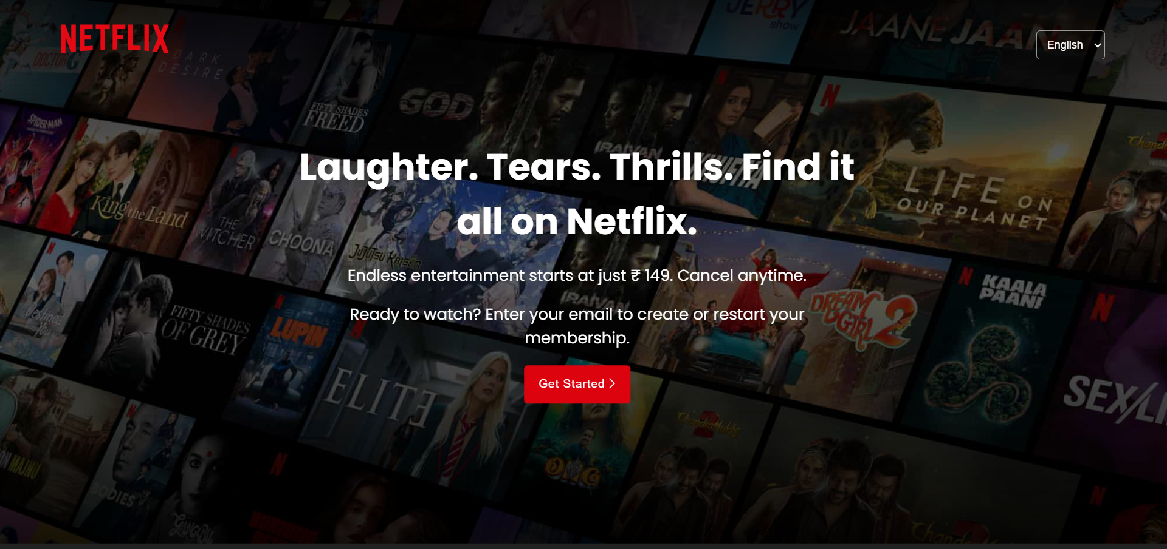 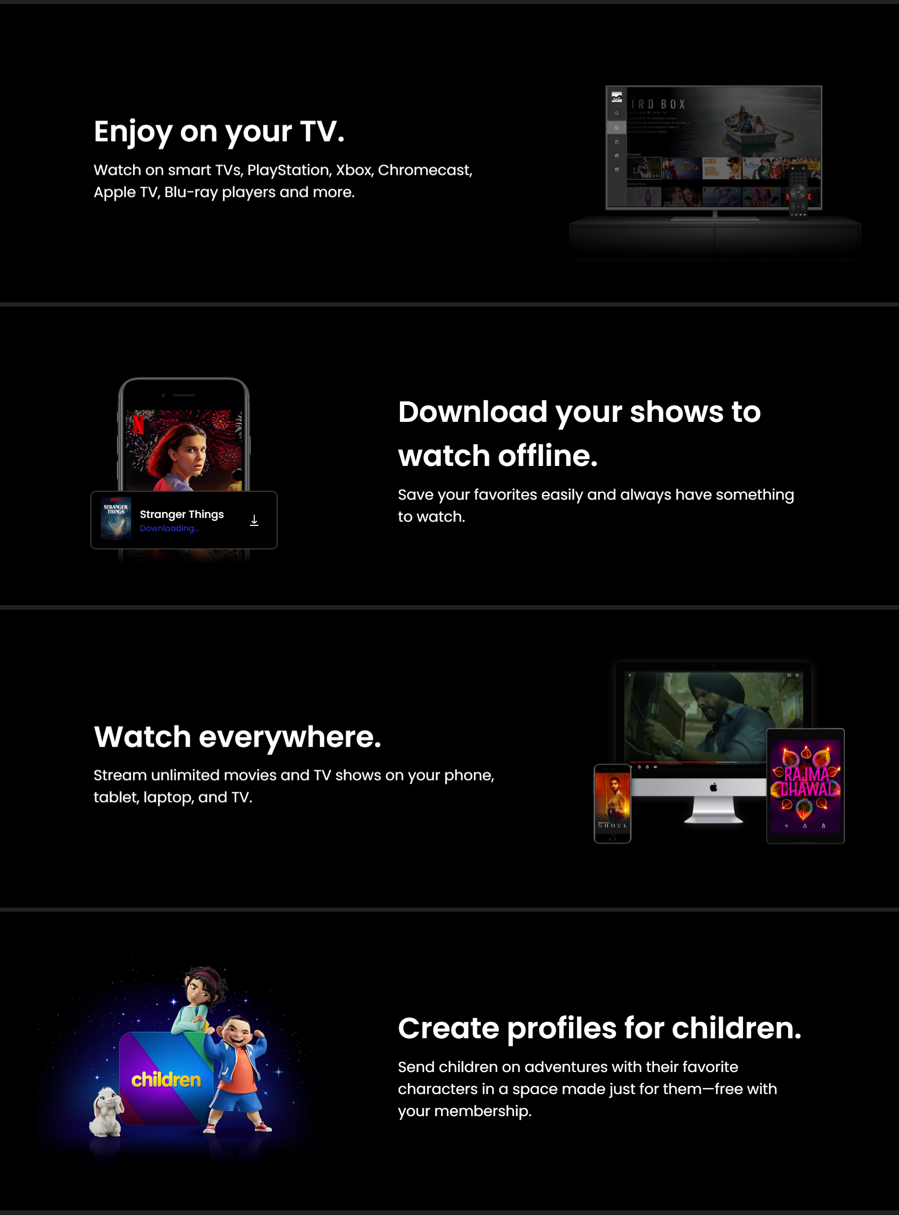

Figure : HOME PAGE

 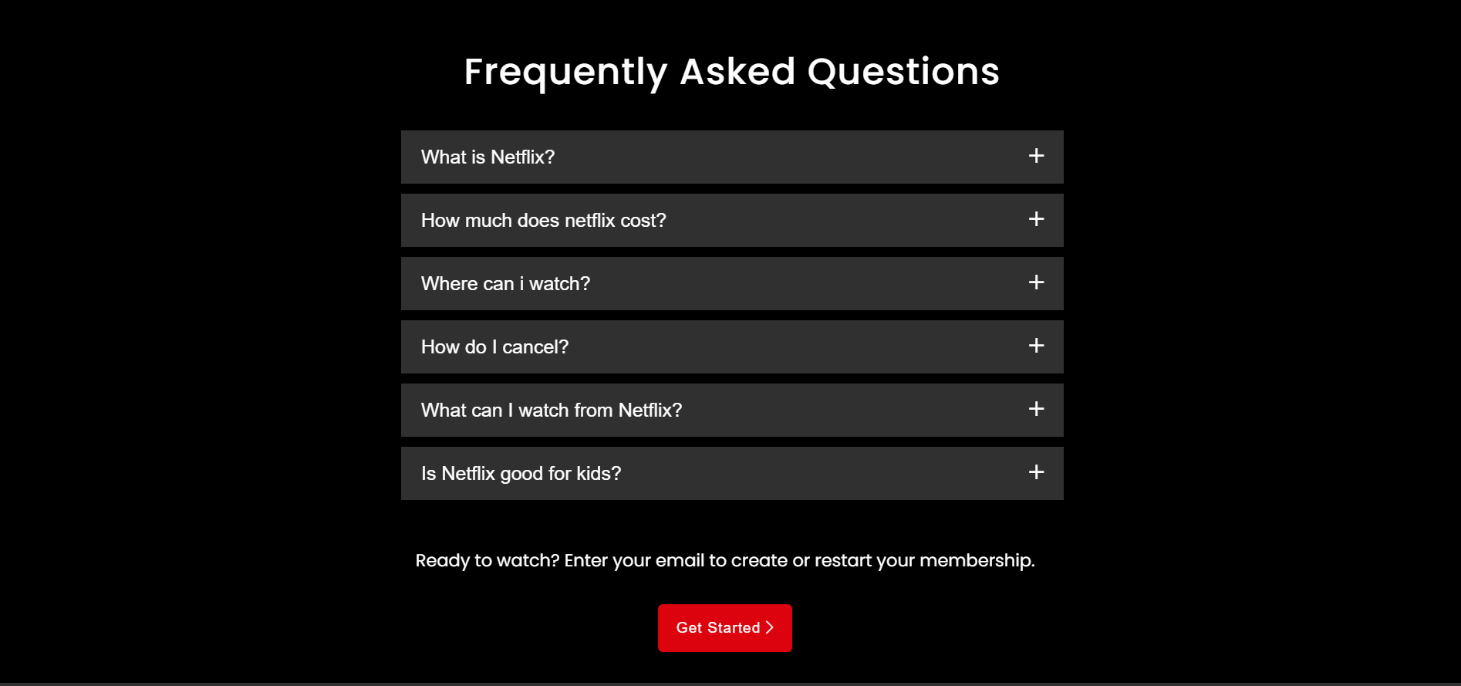

Figure : FAQS PAGE

**SIGN UP PAGE:**

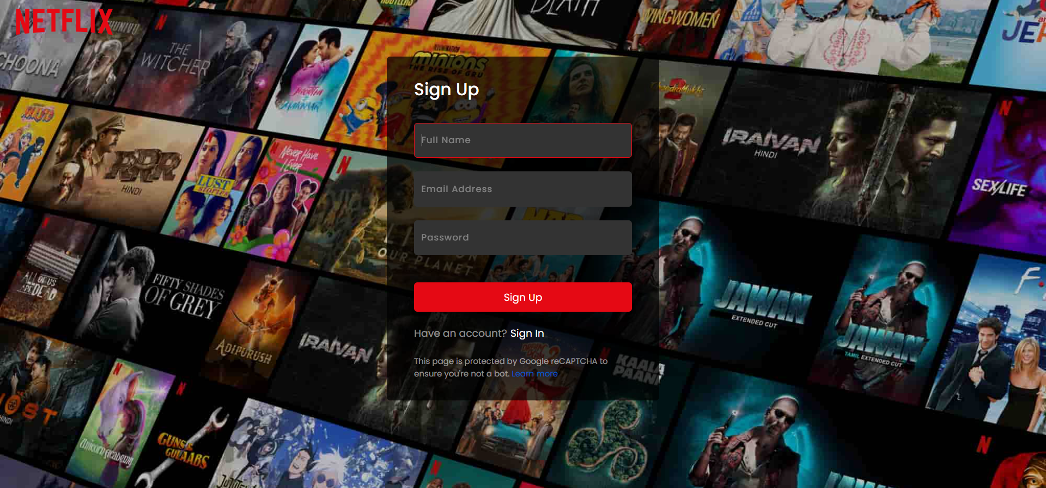

Figure : SIGN UP PAGE

**SIGN IN PAGE:**

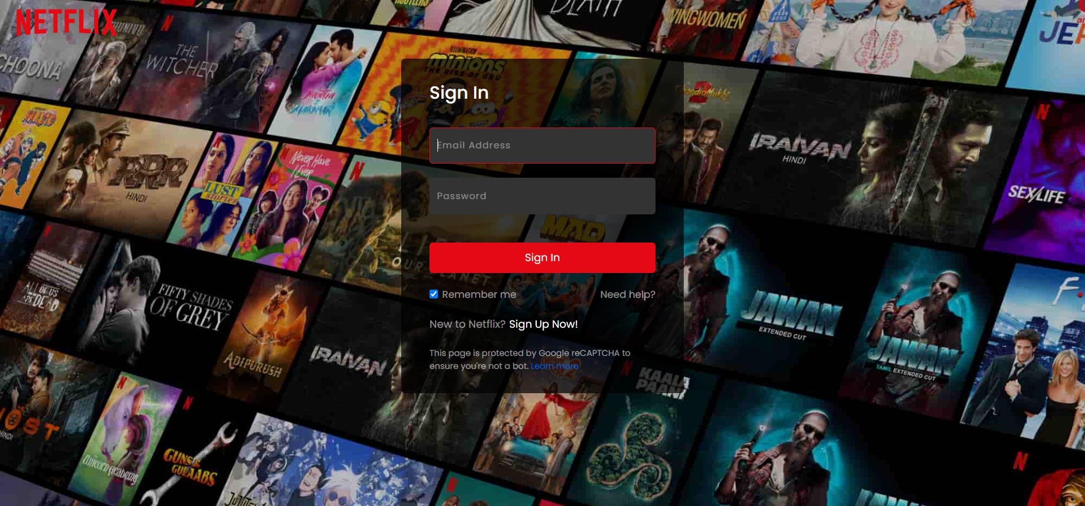

Figure : SIGN IN PAGE

**MOVIES PAGE:**

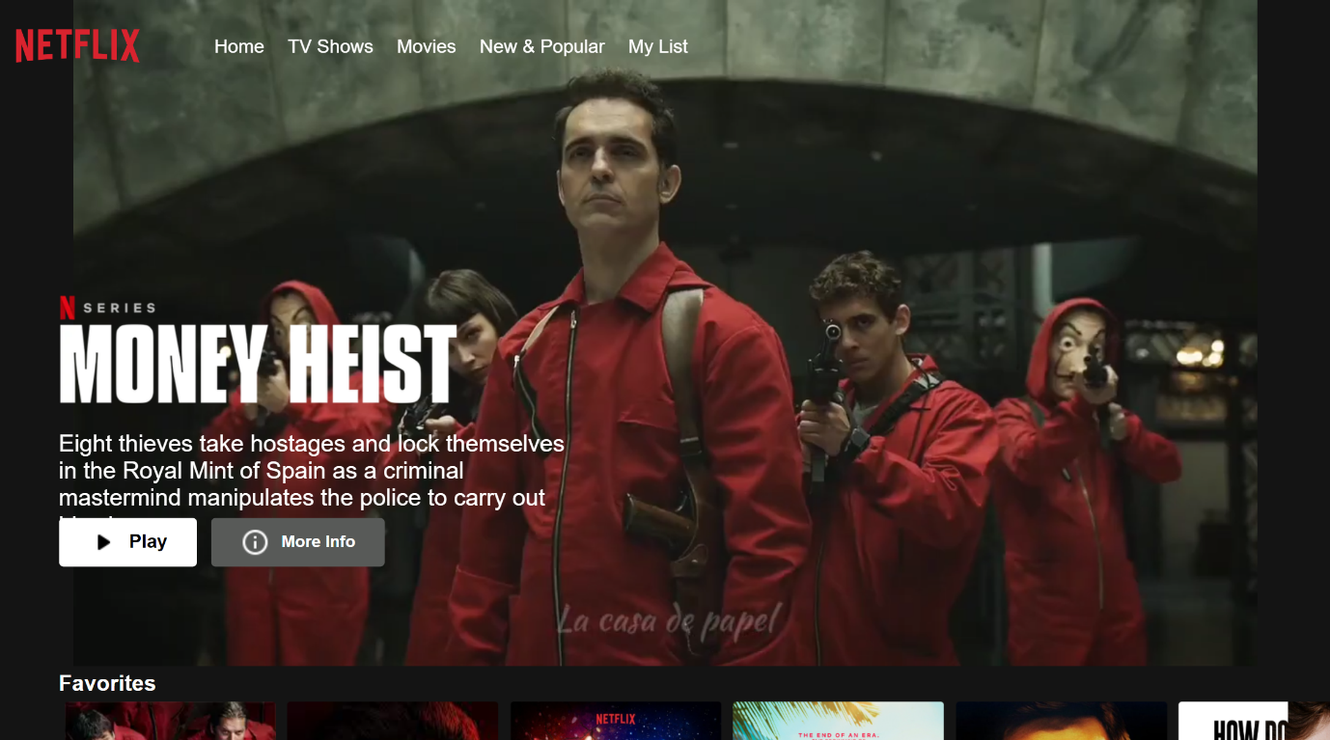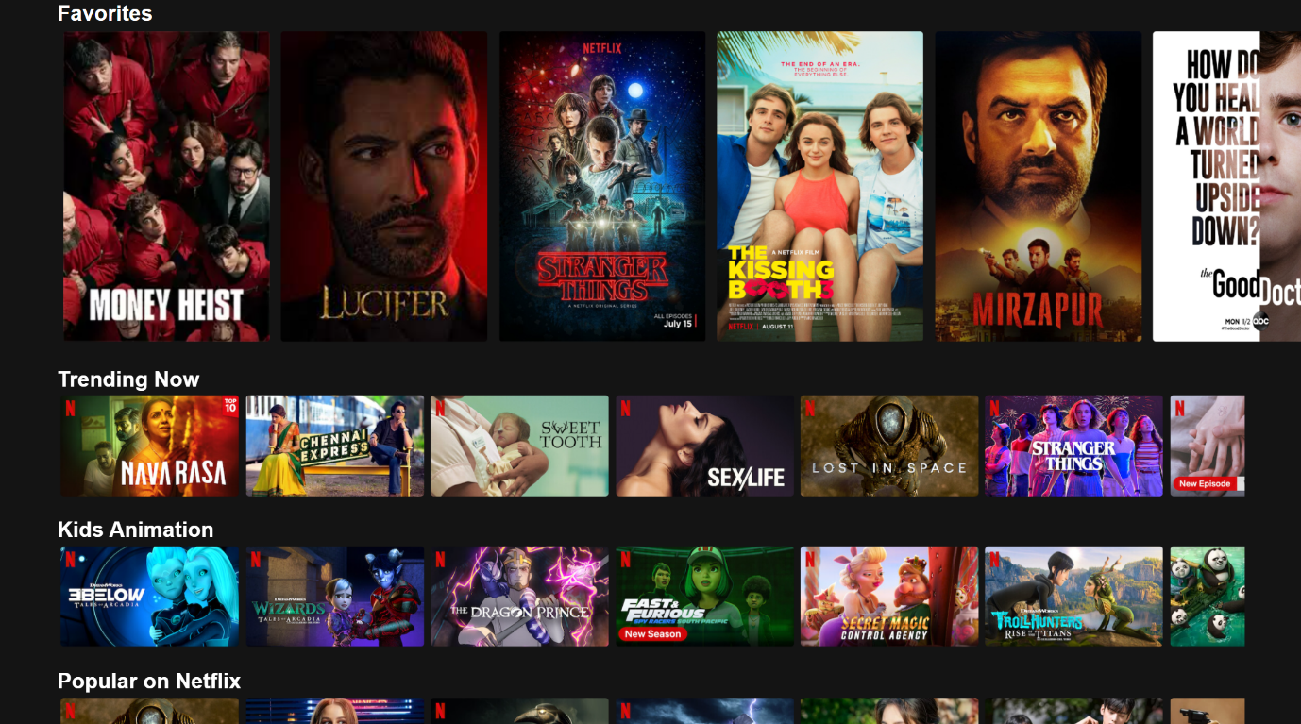 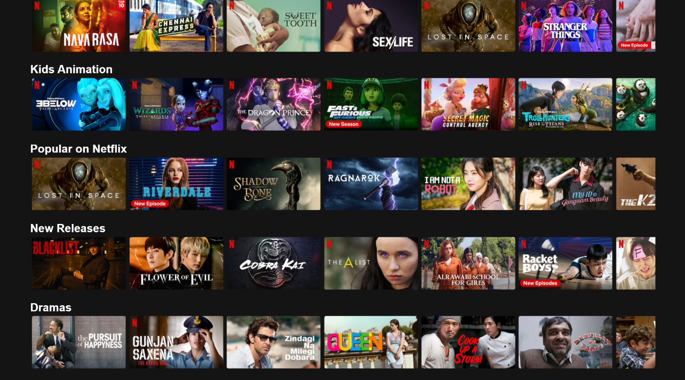

Figure : MOVIES PAGE

**4.3) REFRENCES:**

1. Udemy (https://www.udemy.com/): Udemy offers a variety of web development courses, including ones that focus on building streaming platforms and Netflix clones. You can search for courses related to HTML, CSS, JavaScript, PHP, and SQL to get started.

2. Coursera (https://www.coursera.org/): Coursera provides online courses in web development and programming. You can find courses from top universities and institutions to learn the necessary skills for your project.

3. edX (https://www.edx.org/): edX offers courses from universities and institutions worldwide. You can explore courses related to web development, HTML, CSS, JavaScript, and other relevant technologies.

4. YouTube (https://www.youtube.com/): YouTube hosts many web development tutorials. Search for channels or playlists that focus on building a Netflix Clone or streaming platform to find step-by-step guides.

5. GitHub (https://github.com/): GitHub is a code repository where you can find open-source projects related to web development. You can explore existing projects and learn from their source code.

6. Stack Overflow (https://stackoverflow.com/): Stack Overflow is a community of developers who ask and answer questions related to programming. It can be a helpful resource when you encounter coding challenges during your project.

Remember to carefully review the course descriptions and prerequisites to ensure they align with your project goals and skill level. Good luck with your Netflix Clone project!